24F-0040
Laiba
Problem 03
#include<iostream>
#include<queue>
using namespace std;
class Node{
public:
int data;
Node* left;
Node* right;
Node(){}
Node(int val) {
data = val;
left = nullptr;
right = nullptr;
}
Node* create();
void preorder(Node* root);
void inorder(Node* root);
void output(Node* root);
};
Node* Node::create() {
int data;
cout << "Enter a node to add in tree(-1 for empty node): ";
cin >> data;
if (data == -1) {
return nullptr;
}
Node* new_node = new Node(data);
cout << "\nEnter left child of " << data<<":\n";
new_node->left = create();
cout << "\nEnter right child of " << data<<":\n";
new_node->right = create();
return new_node;
}
void Node::preorder(Node* root) {
if (root == nullptr) {
return;
}
cout << " " << root->data;
preorder(root->left);
preorder(root->right);
}
void Node::inorder(Node* root) {
if (root == nullptr) {
return;
}
inorder(root->left);
cout << " " << root->data;
inorder(root->right);
}
void Node::output(Node* root) {
if (root == nullptr) {
return;
}
queue<Node*> q;
q.push(root);
while (!q.empty()) {
Node* curr = q.front();
q.pop();
if (!curr) {
cout << " NULL";
continue;
}
cout << " " << curr->data;
if (curr) {
q.push(curr->left);
q.push(curr->right);
}
}
}
int main() {
Node n1;
Node* root=n1.create();
cout << "\nPreorder:";
n1.preorder(root);
cout << "\nInorder:";
n1.inorder(root);
cout << "\nOutput:";
n1.output(root);
return 0;

}
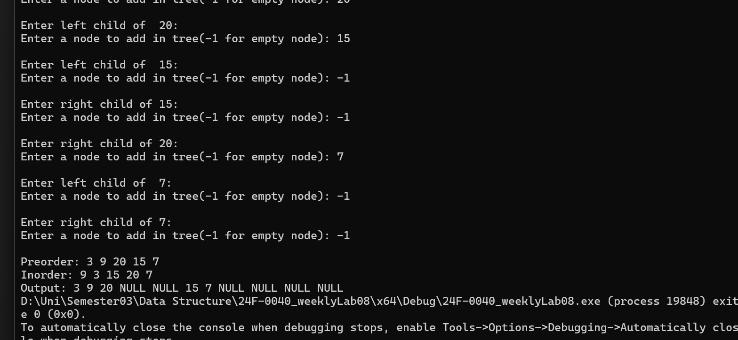
Problem 04
#include<iostream>
#include<queue>
using namespace std;
class Node {
public:
Node* left;
Node* right;
int data;
Node() {}
Node(int val) {
data = val;
left = nullptr;
right = nullptr;
}
Node* create();
void postorder(Node* root);
void inorder(Node* root);
void output(Node* root);
};
Node* Node::create() {
int data;
cout << "Enter data(-1 for no node): ";
cin >> data;
if (data == -1) {
return nullptr;
}
cout << "\nEnter data for left child of " << data << endl;
Node* new_node = new Node(data);
new_node->left = create();
cout << "\nEnter data for right child of " << data << endl;
new_node->right = create();
return new_node;
}
void Node::postorder(Node* root) {
if (root == nullptr) {
return;
}
postorder(root->left);
postorder(root->right);
cout << " " << root->data;
}
void Node::inorder(Node* root) {
if (root == nullptr) {
return;
}
inorder(root->left);
cout << " " << root->data;
inorder(root->right);
}
void Node::output(Node* root) {
if (root == nullptr) {
return;
}
queue<Node*> q;
q.push(root);
while (!q.empty()) {
Node* curr = q.front();
q.pop();
if (!curr) {
cout << " NULL";
continue;
}
cout << " " << curr->data;
if (curr) {
q.push(curr->left);
q.push(curr->right);
}
}
}
int main() {
Node n1;
Node* root = n1.create();
cout << "\nPost order: ";
n1.postorder(root);
cout << "\nInorder: ";
n1.inorder(root);
cout << "\nOutput: ";
n1.output(root);
return 0;
}
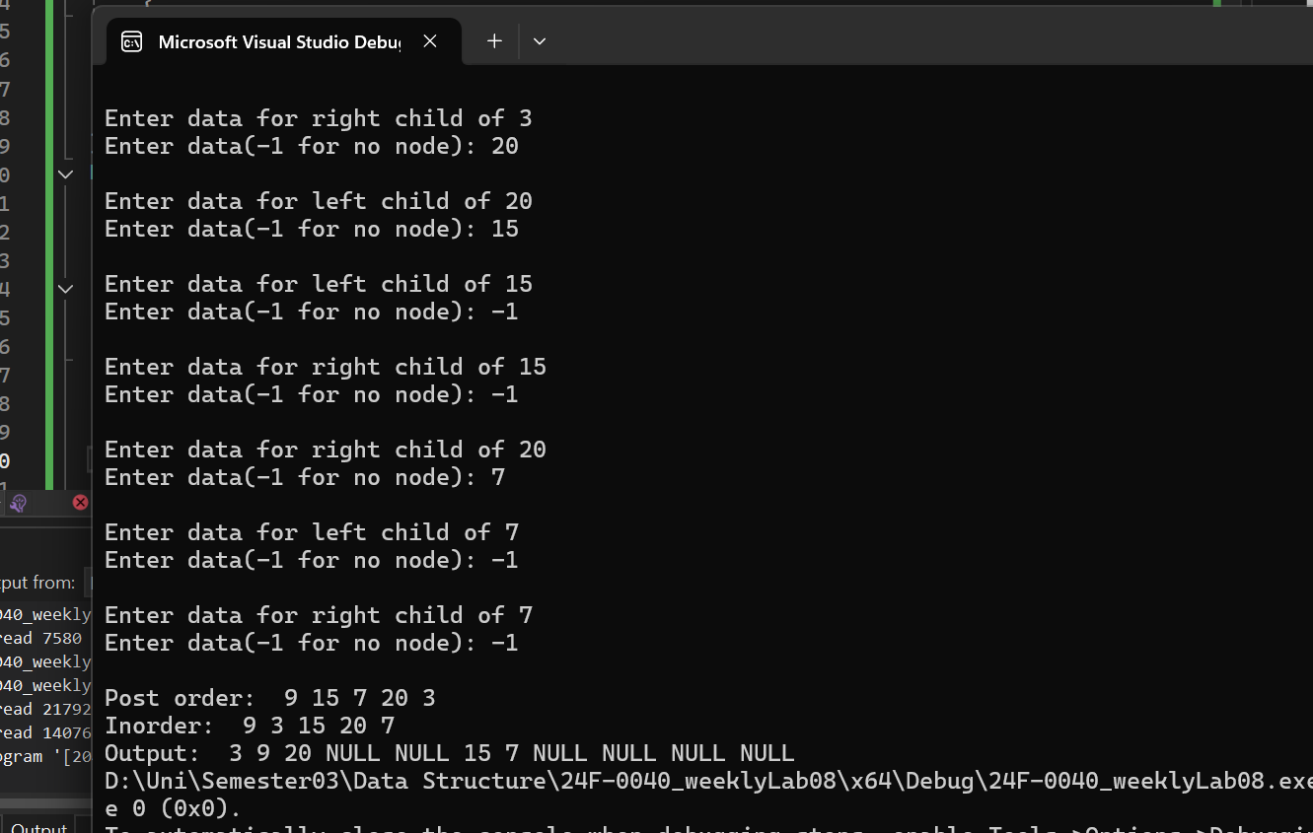
Problem 05

